2018 Sophomore Spring Research Project
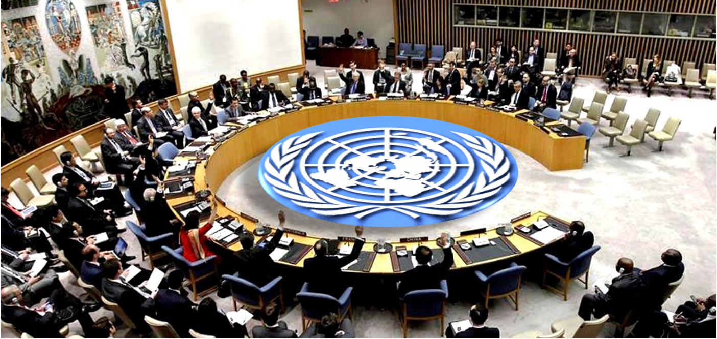

Due: May 7th 2018
International organizations serve as crucial forces for coordination and cooperation on many political, economic, social, military and cultural issues. During the years leading up to and even more so following the Second World War several international organizations were created to combat global problems.
These include:

- The United Nations  - North Atlantic Treaty Organization (NATO)  - The European Union  - South East Asia Treaty Organization (SEATO)  - World Bank  - World Trade Organization (WTO)  - World Zionist Organization (WZO)  - Jewish National Fund (JNF)  - International Atomic Energy Agency (IAEA)  - United Nations Environment Programme (International)  - UNESCO  - NAFTA | - Climate Change (Kyoto Protocol)  - British Commonwealth  - Doctors without Borders  - The United Nations Children’s' Fund (UNICEF)  - Amnesty International  - International Criminal Court  - Greenpeace  - Organization of the Petroleum Exporting Countries (OPEC)  - World Health Organization (WHO)  - European Environment Agency (EEA) Europe but under the UN  - CARE International (Fights global poverty)  - United Nations Framework Convention on

You will research one of these organizations and write a paper outlining the following:
Research
For parts one and two of the paper will need to visit the website for your chosen organization. You need to print and annotate the important sections to hand in with your paper. For part three you will need to gather at least 4 reputable sources such as scholarly journals or reliable newspapers or magazines. These will also need to be annotated and handed in.

Part I: Historical background (1-2 pages)
Explain why this organization was created? What was/were the historical problem/problems that the organization was created to combat.

Part II: Organization structure (1-2 pages)
Who are the members of this organization? What is its objectives?

Part III: Impact of the organization (2-3 pages)
In what ways has the organization you selected impacted the world? Provide a specific example. Has the organization been successful in accomplishing its objectives? What future challenges does it face? What are the different views of the organization? Provide at least one example of both positive and negative views of the organization. You should also add your own opinion of the organization in the conclusion of your essay.

The essay must be typed, follow MLA format, be no longer than 6 pages and uploaded to Turnitin.com.

Class id- 17384855

Enrollment key Mrlazar

